**Database Users and Administrators:**

There are a number of users who can access or retrieve the data on demand using the application and the interfaces provided by the Database Management System (DBMS).

**Types of Users**

The users of the database can be classified into the following groups −

**Native users** − The native users need not be aware of the presence of the database system. They are end users of the database who works through a menu driven application programs, where the type and range of response is always indicated to the user

**Online users** − Online users may communicate with databases directly through an online terminal or indirectly through user interface and application programs.

**Sophisticated Users** − They are those users who interact with the system without writing the program instead they form their request in database query language. They are the SQL programmers, who are going to deal directly with the database. They write queries to delete or select or insert and update the database.

**Specialized Users** − Specialized users who write specialized database applications that do not fit into the fractional database processing framework.

**Application Programmer** − The application programmer users who are responsible for developing the application programs or user interface. The application programs could be written in high level language. For example − Java, .net, php etc,

**Database Administrator (DBA)** − It is a person or the group in charge of implementing the database system within the organization. The DBA has all the privileges allowed by the DBMS and can assign or remove the privileges from the users.

**Classification of Users**

DBMS mainly classified into three users −

* End Users.
* Application Programmers.
* Database Administrator.

The classification of users in DBMS is pictorially represented below −

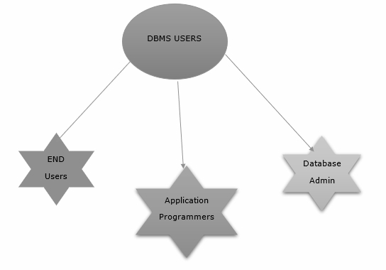

**End Users:**

End users are going to perform various database operations like querying, updating and generating reports.

The different types of end users are as follows −

* Casual end users
* Parametric end users
* Sophisticated end users
* Standalone users

## Casual end Users

The casual end users access the database occasionally. Each time they access the database their request will change.

They use sophisticated database query language to retrieve the data from the database.

Example − High level managers who access the data weekly basis.

## Parametric end users

Parametric end users spend most of their time in querying and updating the database using standard types of queries.

They make up a large section of the end-user population.

Example − A bank teller who does this activity for an entire shift of operations.

## Sophisticated end users

The sophisticated end users access the database to implement their own applications to meet their specific goals.

These include business analysts, engineers, scientists which are familiar with the system capabilities.

The users interact with the system without writing programs. They submit each query to a query processor.

## Standalone users

The standalone end users maintain their own database by creating one using the ready-made program packages that provide a graphical user interface.

The different categories of the end users in the database management system (DBMS) are given in the chart below −

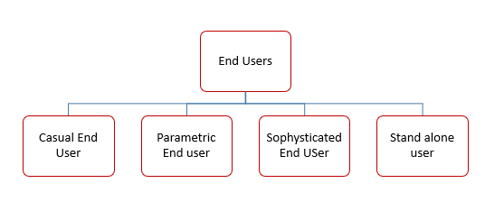

**Roles of Database Administrator (DBA):**

A database administrator (DBA) is a person or group in charge of implementing DBMS in an organization. The DBA job requires a high degree of technical expertise. DBA consists of a team of people rather than just one person.

The primary role of Database administrator is as follows −

* Database design
* Performance issues
* Database accessibility
* Capacity issues
* Data replication
* Table Maintenance

## Responsibilities of DBA

The responsibilities of DBA are as follows −

* Makes the decision concerning the content of the database.
* Plans the storage structure and access strategy.
* Provides the support to the users.
* Defines the security and integrity checks.
* Interpreter backup and recovery strategies.
* Monitoring the performance and responding to the changes in the requirements.

## Skills required for DBA

The skills required to be a successful DBA are as follows −

* Database designing.
* Knowledge of Structured Query Language (SQL).
* Know about distributed architecture.
* Knowledge on different operating servers.
* Idea on Relational Database Management System (RDBMS).
* Ready to face challenges and solve the problems quickly.

The role of DBA is as shown below −

